SA-106/SA-106M 2013 SECTION II, PART A Page : 202

16.2 Diameter — Except as provided for thin-wall pipe
in paragraph 11.2 of Specification A 530/A 530M, the tolerances
for diameter shall be in accordance with the following:

16.2.1 Except for pipe ordered as special outside
diameter tolerance pipe or as inside diameter tolerance
pipe, variations in outside diameter shall not exceed those
given in Table 3.

TABLE 3
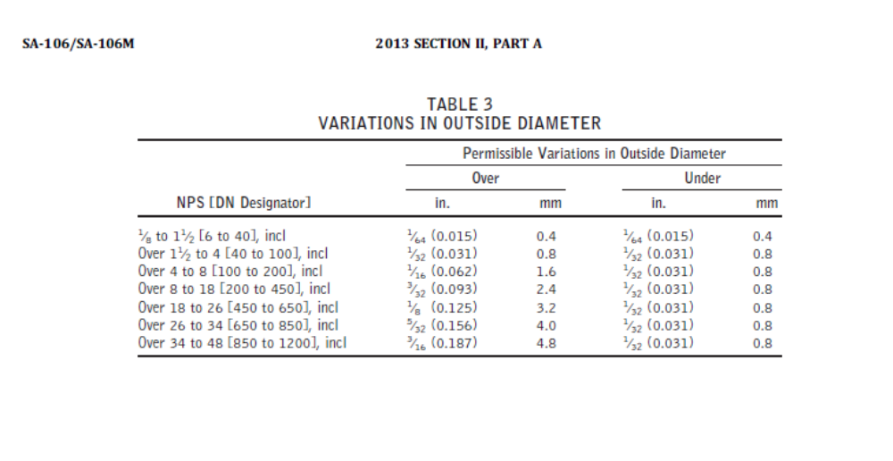
16.2.2 For pipe over 10 in. [250 mm] OD ordered
as special outside diameter tolerance pipe, the outside
diameter shall not vary more than 1% over or 1% under
the specified outside diameter.

16.2.3 For pipe over 10 in. [250 mm] ID ordered as
inside diameter tolerance pipe, the inside diameter shall
not vary more than 1% over or 1% under the specified
inside diameter.

16.3 Thickness — The minimum wall thickness at any
point shall not be more than 12.5% under the specified
wall thickness.

SA-530/SA-530M 2013 SECTION II, PART A

10. Permissible Variations in Outside Diameter

10.1 Variations in outside diameter, unless otherwise
specified, shall not exceed the limits prescribed in Table
2. The tolerances on outside diameter include ovality
except as provided for in 10.2 and 10.2.1.

10.2 Thin-wall pipe usually develops significant ovality
(out-of-roundness) during final annealing, straightening, or
both. Thin-wall pipes are defined as having a wall thickness
of 3% or less of the outside diameter.

10.2.1 The diameter tolerances of Table 2 are not
sufficient to provide for additional ovality expected in thinwall
pipe and are applicable only to the mean of the extreme
(maximum and minimum) outside diameter readings in
any one cross-section. However, for thin-wall pipe the
difference in extreme outside diameter readings (ovality)
in any one cross-section shall not exceed 1.5% of the
specified outside diameter

